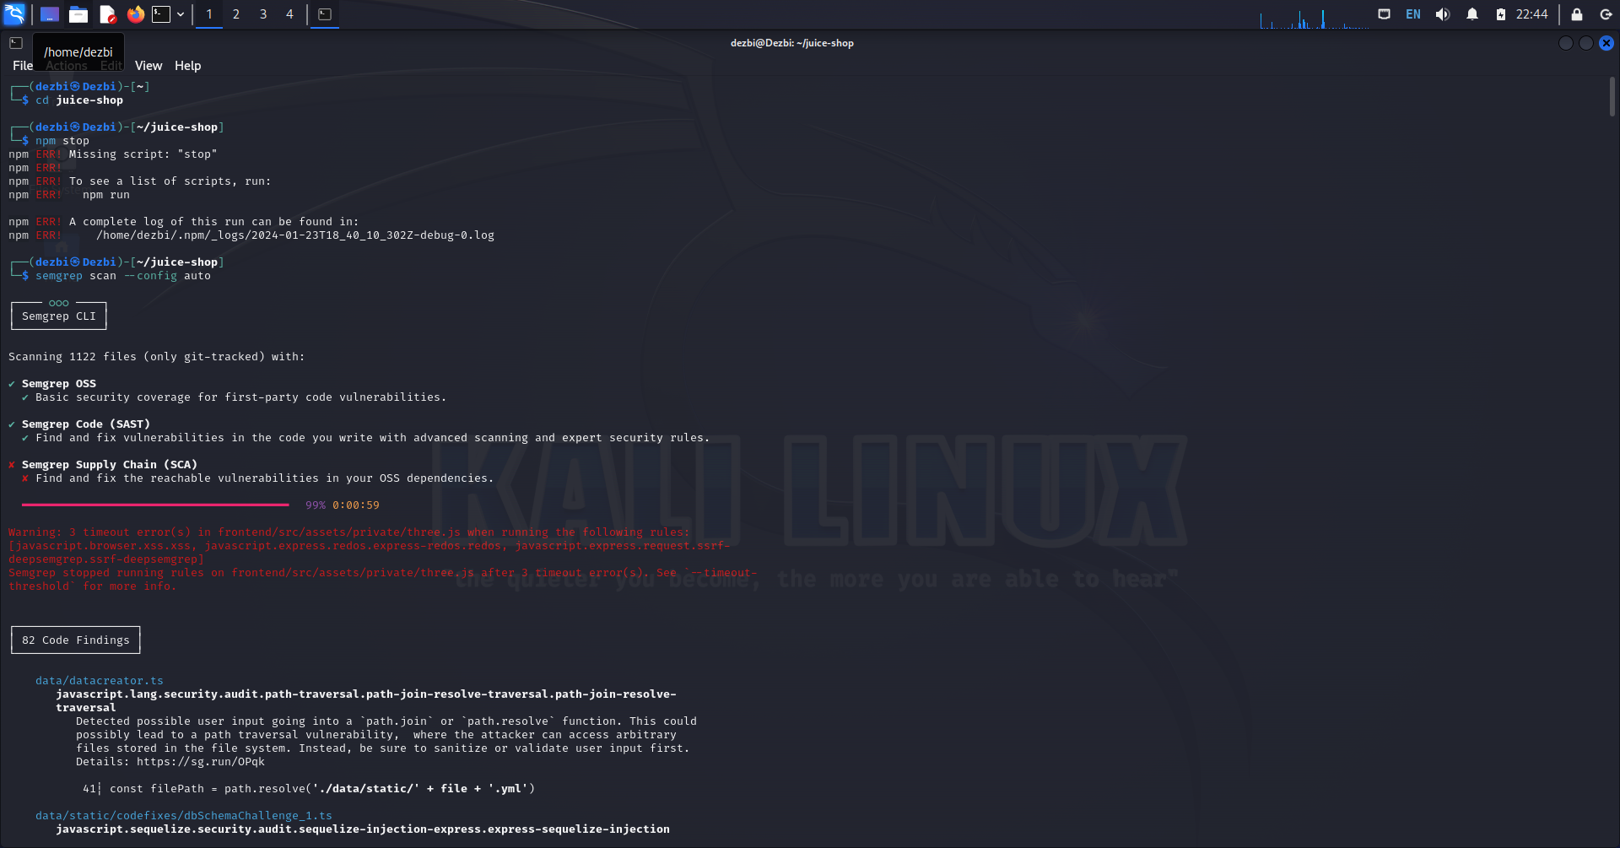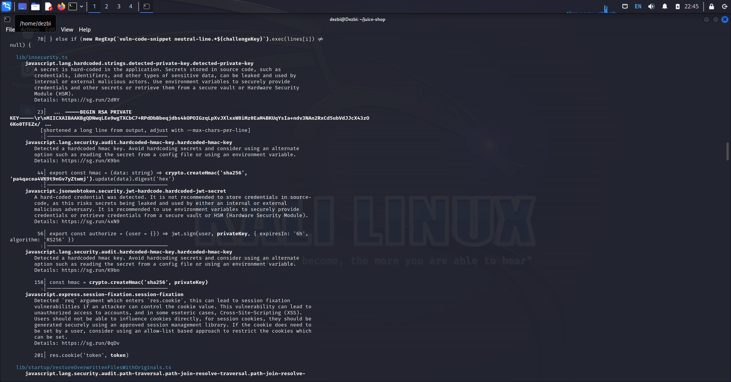

Найденные уязвимости

Cross-Site Scripting (XSS)

## SQL Injection (SQLi)

## Broken Access Control

## Insecure Direct Object References (IDOR)

## Sensitive Data Exposure

SQLi (Burp) 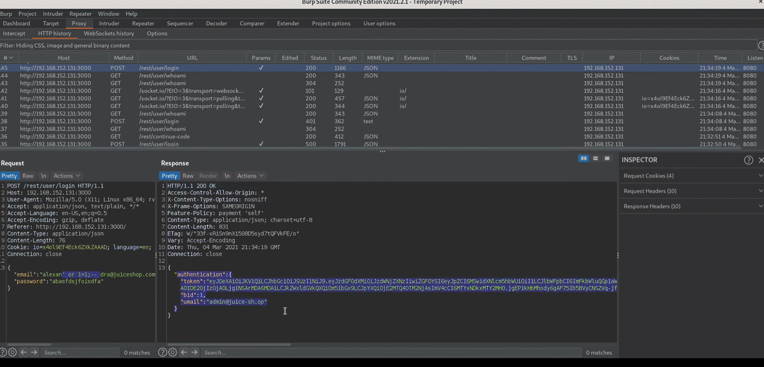

Brocken acces control

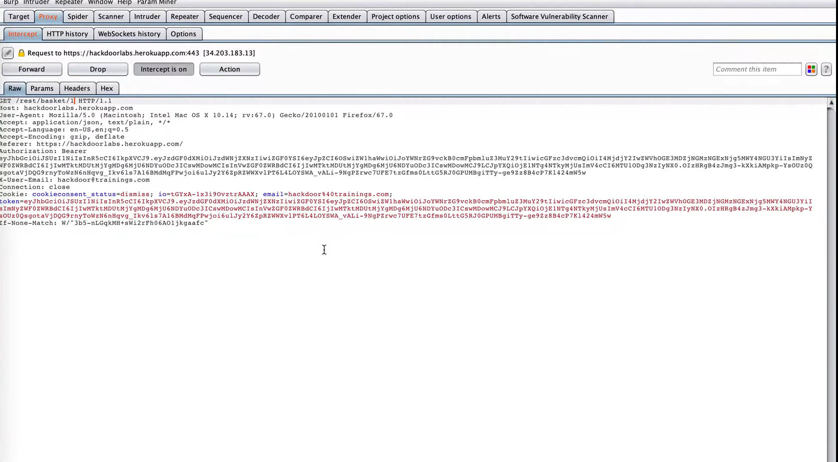

Cross-Site Request Forgery

